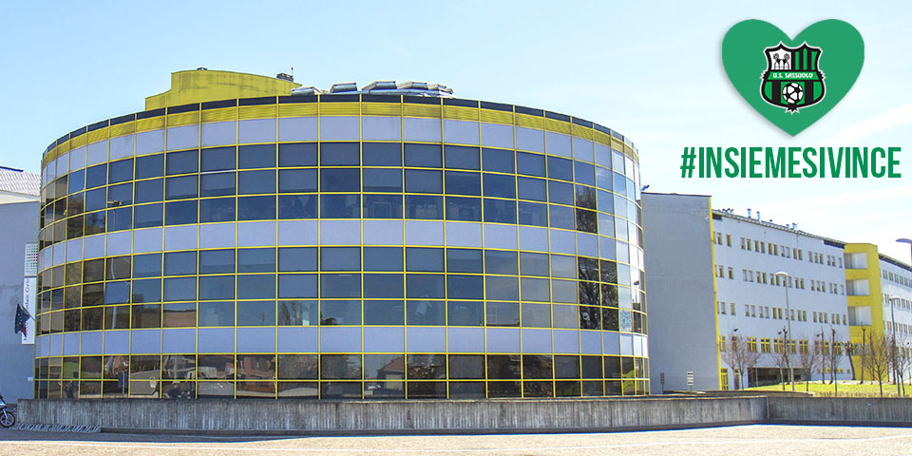

Sassuolo Calcio and Squinzi family to Sassuolo Hospital: #INSIEMESIVINCE

U.S. Sassuolo Calcio and Squinzi family gave their contribution to the operational structures on the territory in this moment of serious health emergency due to the epidemiological spread of the Covid-19 virus in Italy.
The black&green club has donated 100.000 euros in favor of Sassuolo Hospital, engaged in the front line with its medical and health care staff to guarantee the health of Sassuolo’scommunity and beyond.
The donation is aimed at the direct purchase of personal protection devices and equipment for intensive care.
Anyone willing to contribute to help Sassuolo Hospital at this time of emergency can do so in many ways:
MONETARY DONATIONS
- to Ospedale di Sassuolo S.p.a. by bank transfer to IBAN IT42M 03069 67017 100000002263 indicating "emergenzaCovid” (Covid emergency) as the reason. A certificate of donation will be issued (not deductible for tax purposes);
- to Fondazione Ospedale di Sassuolo O.n.l.u.s. by bank transfer to IBAN IT74S 02008 67016 000102982966 indicating "emergenza Covid” (Covid emergency) as the reason. A tax-deductible receipt will be issued.
DONATION OF PERSONAL PROTECTION DEVICES / FOOD AND CONFORT GOODS / OFFERING SERVICES or COLLABORATIONS
- you must contact Sassuolo Hospital directly by calling (+39)0536 846294
Now, more than ever, we need everyone's help: #insiemesivince!

