Reference Project Name:

Restoration of the façade of the architecture and civil engineering faculty building of the University of Guanajuato

CATEGORY : B/ PUBLIC SPACES HOSPITAL/SCHOOL

Project Overview:
- Explain the problem, and the challenge
Due to lack of maintenance and other environmental factors, the facade of the building of the faculty of architecture and civil engineering of the University of Guanajuato began to crumble three years ago. The challenge was to restore the facade with new reinforced materials capable of withstanding the various environmental pressures to which the building is exposed daily, such as:
a. Vibrations caused by a traffic underpass located just under the building's main entrance.
b. Humidity caused by a lack of waterproofing of the original construction materials
c. Materials used on the wall finishing were coming to the end of their useful life
In addition to the façade needing to be restored, it also had to be painted following the color scheme that is compliant with the building codes of the city of Guanajuato as a world heritage site.

- Explain the Mapei solution
The MAPEI local distributor along with MAPEI technical department work with the lead architect of the project to develop a hybrid restoration system for two main restoration issues: the vibrations coming from the nearby underpass and the humidity that already exists in the walls to be refinished.
A combination of structural reinforcement grids and nets were employed:
- Mapenet 150 in combination with Mapei Ecolastic to address a general wall finishing and the humidity of the walls
- Mapenet 40 in the upper part of the walls (which experience the most vibrations)
- Mapegrid 120 to reinforce the veneer elements and address the vibration issues
- Mapei - Vitruvio Repello base as a base coat to the overall wall finishing
- Mapei – Vitruvio Afine as a wall finishing coat
- Mape - antique Rinzaffo as a base mortar
- Mapeantique Ecolastic for waterproofing
- Consolidante 8020 for green limestone consolidation

Project Background
Provide the context and importance of the project in the country, or according the technical challenge.
The architecture and engineering faculty building of the University of Guanajuato has a long history. It was built in the mid-18th century as a hospital and convent. In the middle of the 19th century the building was abandoned and left idle until 1969 when it was declared as the faculty building for the school of architecture and engineering of the University of Guanajuato.
In these times, due to the constant flooding of a nearby river and because of the works carried out to organize a network of underground streets and avenues connecting the city, the engineers have gradually raised the level of the street and the buildings. That is why the building has been substantially modified. Levels, windows and decorative elements were added. This has created an uneven mosaic of building styles, construction methods, and materials that make restoration challenging.
In addition, the building is located next to the main market of the city and on the outskirts of the main exit of the center of the underground route. Constant traffic causes an enormous amount of vibrations that make lime plastering applications difficult.

Project information

Period of construction: Origen en el siglo XVIII con etapas relevantes en el siglo XIX Y XX
Year of MAPEI involvement: 2019-2020
MAPEI Coordinator: MAX ALVAREZ
Project Owner: Universidad de Guanajuato
MAPEI Distributors: María del Carmen Pérez Díaz
Architect: Arq. Luis Israel Peña Sánchez
General Contractor: Arq. Luis Israel Peña Sánchez
Photographer: XXXX
Project size: 780 M2

MAPEI products used

Vitruvio Repello Base
Vitrubio Acabado Fino
Vitrubio Pintura
Mapenet 40
Mapenet 150
Mapegrid 120
Mapei 8020
Mape Antique Rinzaffo
Mapeantique Ecolastic Part A and Part B
MAPEI products at work on the jobsite:
The philosophy of the local Mapei distributor is that “the product sells itself, if the customer knows the details”. So, before all the restoration activities started, the Mapei team gave a 6 hour on-site seminar on how to properly use Mapei’s materials to the lead Architect, Supervisor, Head Foreman, and some of the construction workers of the Temple. The idea was to get them to be familiar with the products and its benefits as well as the tools and procedures needed for their correct application.
EXTERIOR ACTIVITIES – Façade.
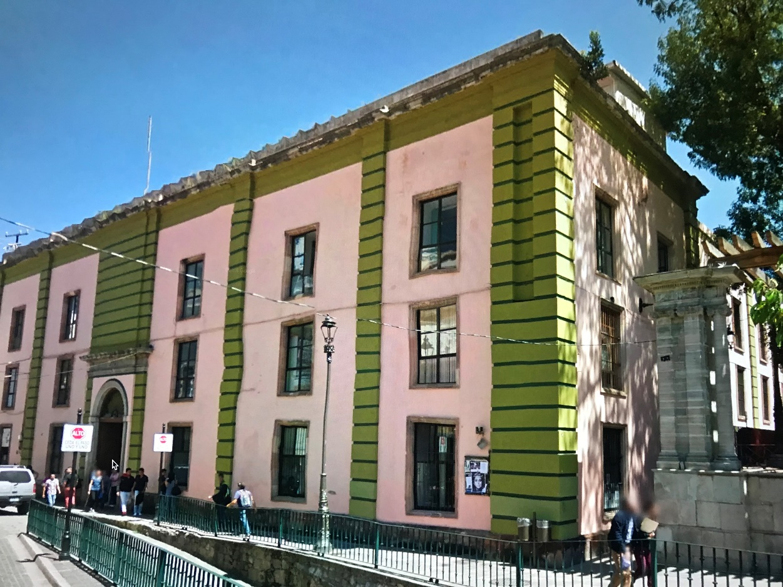

On the exterior applications, the Mapei team provided constant support on-site on the proper use of MAPEANTIQUE RINZAFFO to reintegrate a solid backing for the façade. Taking special care on the large-format and heavy stone application on the dimensionally weak stone (limestone) on the lower part of the façade.
Since old lime finishes simply will not stand-up to the severe weather of the region without proper maintenance, the Mapei team sold an exterior render using a hydraulic lime - MAPEI -VITRUVIO REPELLO – with a MAPEI-VITRUVIO AFINE ACABADO – finish.
The consolidation process on the green limestone, was done with Mapei´s CONSOLIDANTE 8020, in both new pieces that replaced the old ones, and in the original pieces that were kept, after they were properly cleaned, as instructed by Mapei’s experts.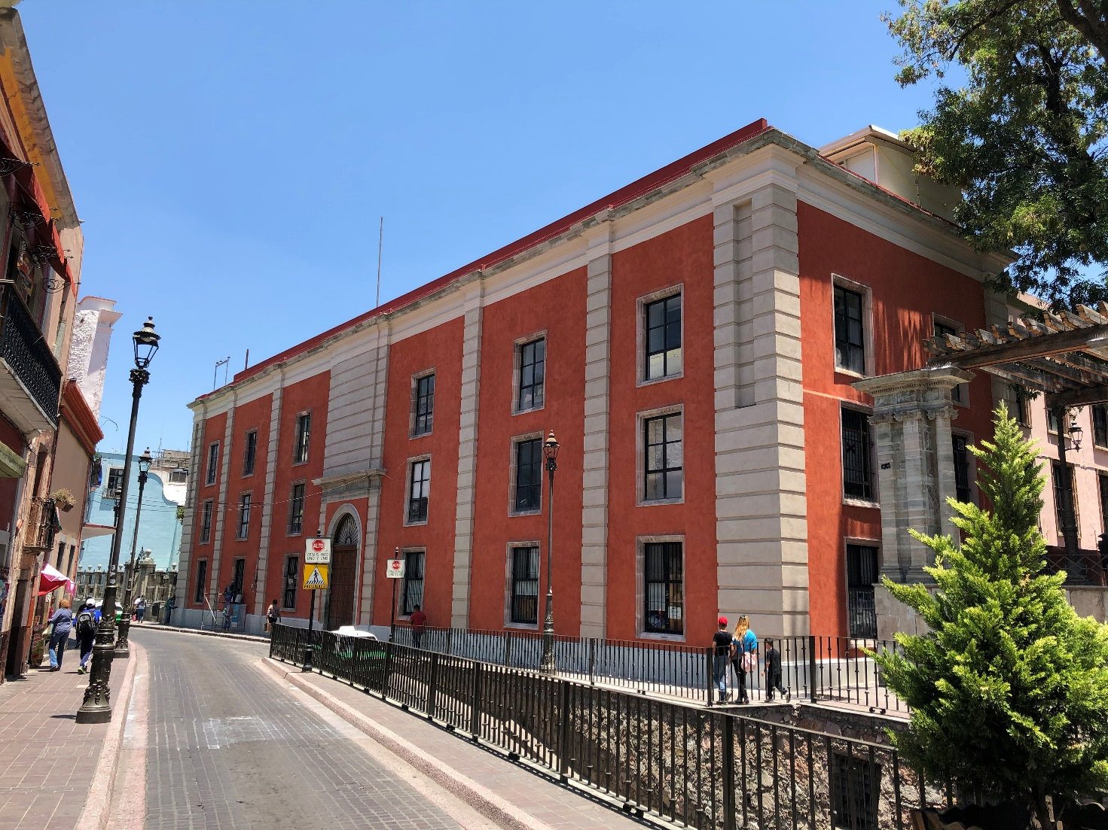

Mapenets and Mapegrid were used to reinforce several elements in the façade, in order to withstand the vibrations of the traffic.

Mapeantique Ecolastic Part A and B was used to waterproof the ceiling

