The Pool Sparkles at Centre Aquatique Dollard des Ormeaux
MAPEI Innovations Restore the Concrete and Help the Tile Sparkle
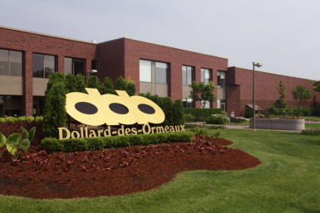
The Dollard-des-Ormeaux Aquatic Centre was built during the first phase of the Dollard-des-Ormeaux Civic Centre. It has been officially open to the public since 1977. The residents are very proud of their aquatic centre. Their web site gives the following information:
“In 1980, the municipality of Dollard-des-Ormeaux recognized the need to create an association to manage the growing number of aquatic programs for its citizens, as well as the citizens of neighboring cities, and thus the Aquatic Association of Dollard-des-Ormeaux (AADDO) was created. The City of Dollard-des-Ormeaux then allowed a right of use of the facility as well as financial grants to the AADDO.
Throughout the years the Dollard-des-Ormeaux Aquatic Centre has evolved into so much more than just a community pool. In keeping with its strong athletic heritage, the Dollard-des-Ormeaux Aquatic Centre has been modernized over the years to include many new recreational amenities, including:
- A 50-metre, 6-lane pool, equipped with a moveable access ramp and lift as well as two 1-metre diving boards. The pool is heated to 27 degrees Celsius.
- A 20 x 10 metre pool, equipped with a permanent access ramp. The pool is heated to 30 degrees Celsius.
- A fitness room, consisting of several cardio machines, strength training machines and free weights.
- A gymnasium with hardwood floors and a full wall mirror, where yoga, aerobics and pilates classes are offered.
- Men’s and women’s locker rooms with dry saunas as well as a family locker room.
The Aquatic Centre is a welcoming environment for all generations. Whether the activity is educational, recreational or competitive in nature, fun and fitness are always the top priority at the Dollard-des-Ormeaux Aquatic Centre.”
As the pool at Dollard-des-Ormeaux aged, the city recognized the need to renovate and refurbish the pool. A number of civic pools in the Quebec area have been undergoing similar renovations, and MAPEI products have been a major factor in at least 6 such projects in the last 2-3 years. The Dollard-des-Ormeaux pool is one of the largest of these restorations. This renovation project was designed by the architectural firm of André Riopel and Associates.
Groupe B. T. Céramiques, Inc. was selected to perform the work at Dollard-des-Ormeaux. Under the project leadership of Alfredo Magalhaes, crews performed both the concrete renovations and the tile-setting for the new pool. Groupe B. T. Ceramiques (GBTC) has become the master of doing large pool restorations in Quebec, and they have been using MAPEI products on their projects for more than 25 years.
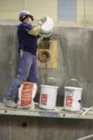
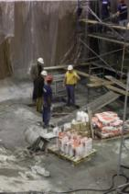
For the Centre Aquatique Dollard-des-Ormeaux, the restoration work began with crews sandblasting the entire surface of the pool bottom, walls, and surrounding “beach” area to give a rough profile. Four round underwater windows used by photographers to capture winning moments in competitions were closed to make the pool more aesthetically pleasing; and new drains were installed in several areas.
GBTC, in consultation with MAPEI representative Domenic Romano, used MAPEI concrete restoration products in a number of innovative ways throughout the renovation. When the main drain at the bottom of the pool was replaced, the team had to remove about 250 square feet of the surrounding space. After the new drain was installed, they filled the void with Planitop FD full-depth concrete mortar mixed with pea gravel. They used this same technique to fill the spaces where the underwater observation windows were closed. The voids filled by the form-and-pour process were 14 inches in diameter and 10 inches deep. In both instances, Planibond EBA was used to enhance the bond between old concrete and new.
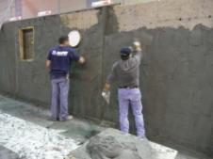
Federation International de Natation (FINA), the international federation for competitive swimming, has very strict requirements for the size of Olympic pools. Planitop 23 repair mortar was used on all vertical walls inside the pool to build them up to FINA requirements. After the sandblasting procedure, 1 ½ to 2 inches of depth had to be added to each wall.
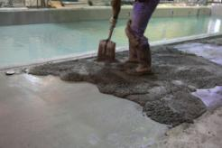
Once the void around the main drain had been fixed, GBTC’s team applied Planibond EBA across the 7,500 square feet of the pool floor. They screeded Mapecem 102 on top of the bonding agent to slope the floor to the right angles and to serve as the substrate for the pool tile.
Topcem Premix, combined with Planicrete AC liquid latex admixture, was used in depths from 1 inch to 2 ½ inches for the beach area surrounding the pool, which had also been sandblasted to a correct profile; Topcem Premix in a liquid form was mixed with a small amount of Planicrete AC to serve as a bonding agent. These products were used by the crews to slope 8,800 square feet of the beach surrounding the pool to the new beach drains.

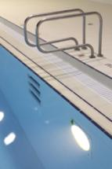
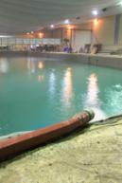
Planigrout 712 was also used for the first time to fill the "inverse steps". GBTC made a form and poured Planigrout 712 into it to make three steps into the pool. They first applied Planibod EBA to enhance bond to the existing concrete, then put in the form, and poured the Planigrout 712. When the form was removed, the results surpassed expectations.
With the surface preparation complete, the waterproofing process began. Mapelastic 315 with mesh was used over all vertical and horizontal surfaces. It was applied in a two-coat system. The first coat was applied, and the mesh was embedded in it. The next day a second coat of Mapelastic 315 was layered on to encapsulate the entire waterproofing system. The waterproofing certainly passed the flood test!

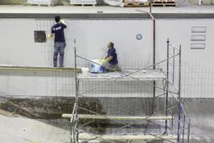
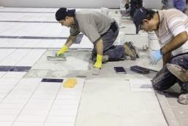
GBTC used a double-mortar technique on the interior of the pool, back-buttering the tiles and applying the Kerabond/Keralastic mortar system to the surface of the pool to insure 100% coverage, which is very important for an underwater installation. Kerapoxy grout was used to obtain an impervious installation and to insure that the color would remain of sharp quality and be easily maintained by the pool operators.

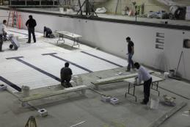

MAPEI gave a 25-year warranty to the city of Dollard-des-Ormeaux for the interior of the pool. For the exterior of the pool, the city was issued a 15-year warranty, which included the beach area. The shorter warranty applied because Topcem Premix was used for economic efficiencies.
The city of Dollard-des-Ormeaux, the architects, the general contractor and all others involved in the project were happy with the results and impressed with the materials and service from MAPEI. Marc Menard, the project manager for the general contractor, Norgereq, Inc., commented, "We had not used MAPEI products in the past. I had never seen so many MAPEI products being used, and with so much success! We will definitely be using it for our future projects.”
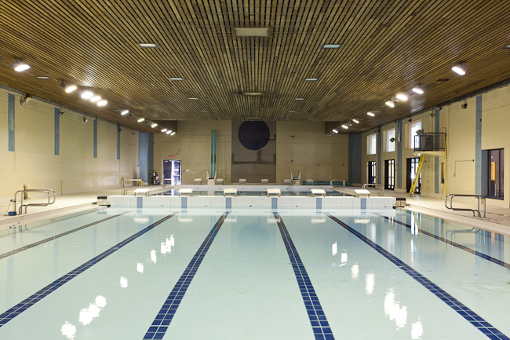
Groupe B. T. Ceramiques is not a company to rest on its laurels. They will soon be starting (July 2011) a new pool project in Montreal called “Rene Goupil”, and they will be using MAPEI’s innovative products to make that pool sparkle, too!
Centre Aquatique Dollard-des-Ormeaux

