McCaig Tower – A New Age of Medical Care in Calgary
MAPEI Products Help Design & Build Project Operate on Schedule for Foothills Medical Centre
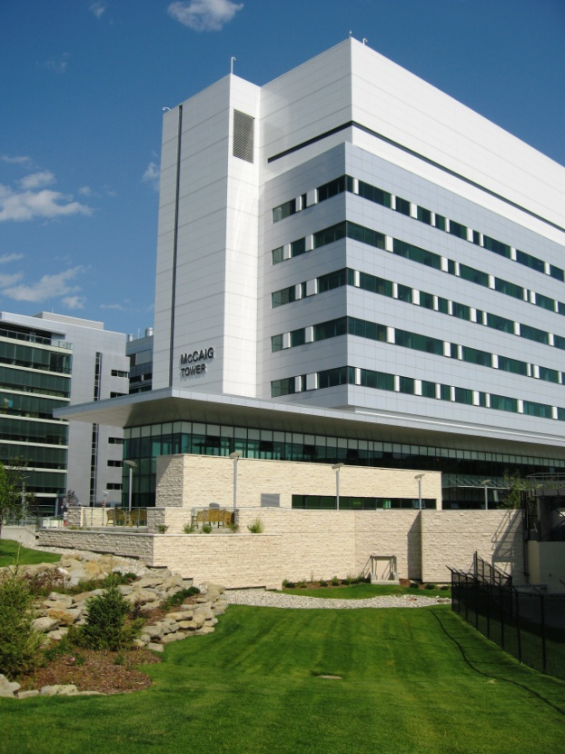
Foothills Medical Centre (FMC) is the largest hospital in Alberta, Canada and is located in the city of Calgary. It is one of Canada's most recognized medical facilities and is one of the leading hospitals in Alberta, providing advanced healthcare services to over two million people from Western Canada and the Prairies. The Foothills Medical Centre is an accredited tertiary trauma centre and is the largest regional trauma centre in Southern Alberta.
Currently, the hospital is undergoing a large expansion with the addition of the new McCaig Tower, which partially opened in October 2010. Named after Alberta philanthropist J.R. (Bud) McCaig, this new addition is the result of a 10-year vision to expand the Foothills Campus, based on the needs of the population of Calgary and surrounding area. The $500-million facility is expected to increase surgical capacity at the Foothills Medical Centre by 10 per cent, adding another 1,000 to the 17,000 surgeries currently performed each year.
When fully operational, the eight-story tower will be home to 23 operating rooms, 93 acute care beds, a 36-bed intensive care unit, 21 short-stay beds, new lab and diagnostic imaging areas as well as a muscular-skeletal clinic and other out-patient services. It will also be equipped with the latest medical technology and specialized infection prevention and control features.
McCaig Tower will incorporate existing services from the Foothills Medical Centre, and the new design - based on world standards for size, proximity and efficiency, will allow for improved delivery of those services. By relocating some of the existing services from the existing buildings of the Medical Centre into the new tower, space will also be created to expand other areas, including the emergency department.
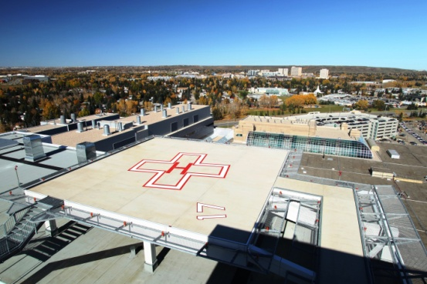
This new facility is the first phase of a major ‘redevelopment’ envisioned for the existing hospital. All aspects of design and planning embrace flexibility, efficiency, functionality and future growth considerations. Although constructed at the ‘back’ of the existing medical centre, a new road system and interchange over Calgary’s 16th Avenue provides a new west entrance to the hospital complex. A new 615 underground parking garage was developed as part of this phase of the project, as well as a new helipad on the roof of the McCaig Tower.
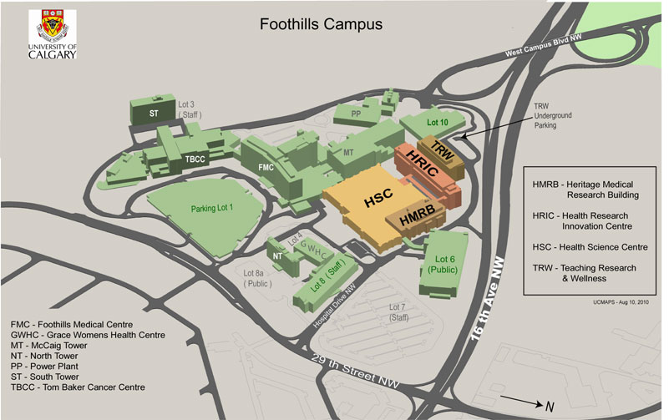

Traditionally, building a hospital takes 36 months of planning followed by 56 months of construction. Sometimes there just isn’t that much time available. To meet the needs of Alberta Health Services and Foothills Medical Centre, the design and build of the McCaig Tower had to take place concurrently. According to Cohos Evamy Integrated Design, the architectural firm for the new tower, the drawings were actually completed 18 months after construction began. In order for design-build projects to be successful, the involvement of construction managers and general contractors is a significant factor. For the McCaig Tower, Ellis Don Construction was the perfect partner.
Fast-track construction and simultaneous design can change the entire picture overnight. Originally designed to be a 12-story building, the McCaig Tower was shortened to four stories early in the design process, then elevated to 8 stories once funding was secured. Different stresses on the concrete being poured for the foundation had to constantly be taken into account.
To offer more efficient, patient-responsive treatment in a surgical/intensive care facility, an innovative new system of “interstitial floors” was also incorporated into the McCaig Tower. The second floor of the hospital will never be seen by patients; but the electrical, mechanical and physical infrastructure housed on this level will make their hospital stay safer and more pleasant. This innovation presented a whole world of new issues and challenges for Ellis Don.
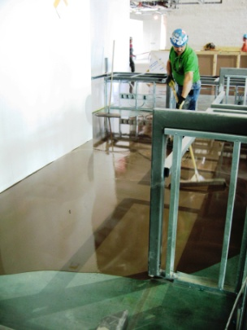
Even the process of pouring the slabs for the eight floors of the hospital produced some unexpected results. When horizontal iron bars are placed between vertical columns to support the concrete pour, they are “arched” to a predetermined camber that levels out as the weight of the concrete settles on them. In this instance the weight of the slabs did not bring the floors completely level. A solution was provided by MAPEI.
Crews from Burton General Contracting of Calgary poured more than 500,000 square feet of Ultraplan® Easy fast-setting self-leveling underlayment on the eight floors. Typically requiring reduced surface preparation, Ultraplan Easy provides lower installation costs and fast turnaround on job sites. It features high strength and is able to withstand light foot traffic after 2 to 3 hours of installation. In areas where the original surface was shotblasted, the crew primed the area with Primer L, a concentrated, solvent-free acrylic latex primer to improve the bond between the substrate and Ultraplan Easy. Where shotblasting was not needed, the Burton teams used Primer WE and Mapeprime 1K, which are designed for non-porous substrates.
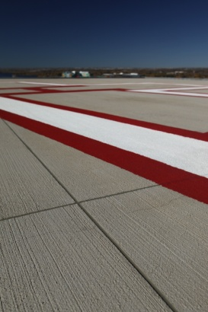
Other areas on the project called for more of MAPEI’s total solutions for concrete repair. For the parking garage being built next to the McCaig Tower, Planiseal™ Plug and Planiseal 88 were used to remedy cracks in the walls that were leaking water into the parking area.
A new helipad was built atop the roof of the McCaig Tower to support Foothills Medical Centre in its role as a trauma center for Southern Alberta. The concrete finish for the helipad did not meet expectations. The pad was heated with glycol lines, and its position on the roof of the building would have made it very costly, if not impossible, to demolish and replace. Once again MAPEI provided a solution. Mapecem Quickpatch was used to patch voids of varying depths, and Concrete Renew was applied over the entire surface with a brushed finish. These two MAPEI products provided a very cost-effective solution for this problem. Planibond JF joint filler was used on the helipad and beneath some of the floor coverings at joints in the substrate.
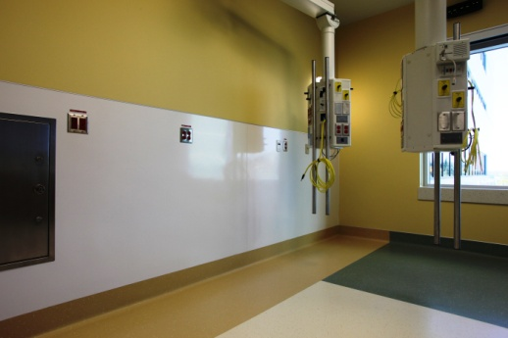
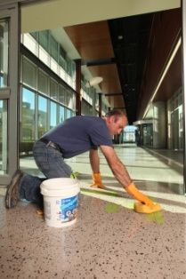
MAPEI products continued to provide solutions inside the McCaig Tower. Ultraflex 2 mortar was used to set tile on 10,000 square feet of floors and walls in the lobbies and bathrooms of the building. In the main lobby and the bathrooms, where heavy traffic and the possibility of staining could become an issue, Kerapoxy, a 100% solids epoxy grout was used to fill the joints between tiles. In other lobbies and common areas, crews from Flesher Marble & Tile used easy-to-apply Keracolor S grout. A long-time user of MAPEI products, Flesher Marble & Tile celebrated the company’s 100th anniversary during the course of this project.
Planiprep FF skimcoating and patching compound was used by crews from KBM Commercial Flooring to prepare substrates for the installation of Armstrong Medintech vinyl flooring. They also used Ultrabond ECO® 575 wall base adhesive to install 90,000 square feet of Altro Whiterock wall covering in surgical suites and other sterile areas. In non-wet areas, they used ECO 575 to set Acrovyn and FRP wall liners.
Having the solutions and making them available to Ellis Don and its sub-contractors made MAPEI a valuable team member for this fast-track design & build project. This is what has made MAPEI “technology you can build on” in Western Canada.

