Luxury amidst Alpine Ruggedness
MAPEI Systems Provide Rugged Solutions for Montage Ski Resort and Spa
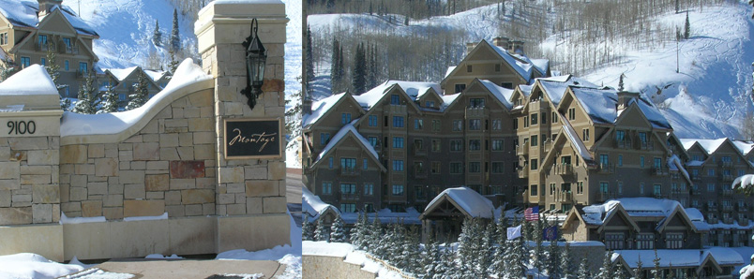
Montage Hotels and Resorts heralded the inauguration of its first major ski resort and spa with the following press release highlights:

“Montage Deer Valley opened today (December 9, 2010) in the year-round community of Park City, Utah, less than five minutes from the historic town's vibrant Main Street and an easy 40-minute drive from Salt Lake City International Airport.
Reminiscent of great mountain lodges, this is the third destination and first mountain resort opening by ultra-luxury hotel company Montage Hotels & Resorts. Set in a grand mid-mountain location at Empire Pass with 154 deluxe guestrooms, and more than 66 suites and private residences, Montage Deer Valley offers true ski-in, ski-out access to Deer Valley Resort.
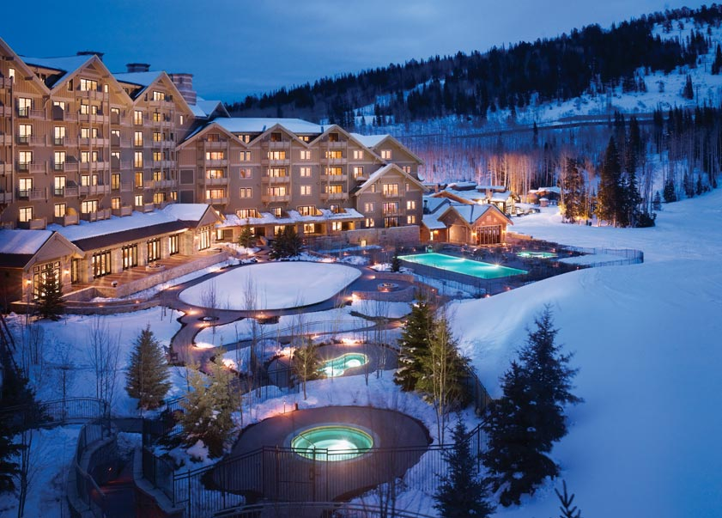
Three high-speed chair lifts are literally outside the resort's front door, providing a true ski-in/ski-out experience. There is also an abundance of activities for non-skiers to enjoy as well, such as sleigh rides, snowshoeing, ice skating, renowned shopping and more.
During warm weather months, guests will discover a whole new palette of alpine activities, including horseback riding, blue-ribbon fly-fishing, championship golf, mountain biking and trail hiking among other adventures. Whatever the season, visitors to the resort can revel in Park City's majestic setting, breathe in fresh mountain air and enjoy the signature 35,000 square-foot alpine inspired Spa Montage.
From the signature restaurant, Apex, a mountain American grill inspired by the freshest farm-to-table ingredients, to Daly's Pub & Rec, [Montage’s] interpretation of a gourmet gastro-pub offering all of the guests favorite pastimes, including bowling and a nostalgic video arcade, [guests will delight in the food and ambience.]
Reflecting its commitment to the arts and true to its name, the Montage Deer Valley is complimented throughout with a museum quality collection of more than 100 paintings and works of art and sculpture influenced by nature, wildlife and western heritage. Innovatively designed and consistent with Montage's sustainable initiatives, Montage Deer Valley is registered to be LEED certified.
All Montage Deer Valley's spacious guestrooms and suites feature fireplaces, expansive outdoor views and baths with heated limestone floors.”
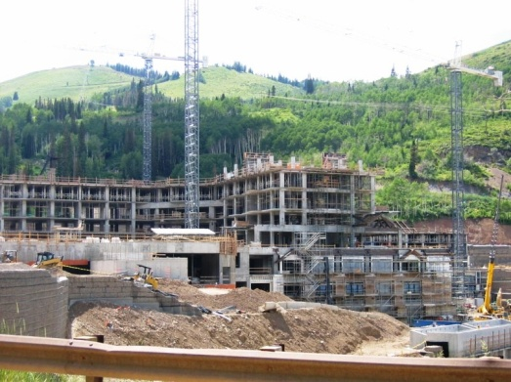
Luxury is the name of the game at Montage Deer Valley, and it comes with a price in the range of $2-10 million for the private residences at the resort. To accommodate their owners and guests, Montage Hotels and Resorts built a quiet space for every mood, from reflective retrospection in the Spa to killer competition on the ski slopes.
RJ Enterprises of Heber, Utah (RJE), did the work on the large outdoor pool at the resort. Much of the building structure would be under wrapped scaffolding as cold weather approached, allowing workers to continue the construction over the winter months; but no such protection was available for the outdoor pool. Robert Hickens and his crew from RJE used fast-track concrete repair products and tile and stone installation systems from MAPEI to get their job done before the snows of winter arrived. Their first challenge came from the pool deck drains. They used Mapecem® Quickpatch to create the correct elevations for drains so they were correctly sloped. Mapecem Quickpatch features extraordinary ease of placement, with a variable water ratio and outstanding workability. Light gray Mapecem Quickpatch can be applied from featheredge to 3” for ramping or filling. Mapecem Quickpatch sets fast for easy and cost-efficient repairs, minimizing job-site turnaround time.
Because of its outdoor location, the pool itself was not tiled, but the RJE crew set 3-inch-thick brick pavers around the pool deck using MAPEI’s rapid-curing Granirapid mortar system. As the industry’s first and only fast-curing system geared for fast-track projects, it develops high, early mechanical strength and cures considerably faster than traditional medium-bed mortars because of its superior drying-out characteristics, which produce low residual moisture behind the tile after 24 hours. Because of its high-hydrating cement technology, Granirapid does not contribute to efflorescence when the pavers are exposed to rough weather or salty de-icing treatments. The same hydraulic characteristics apply to Ultracolor® Plus grout, which was used to fill the joints between the pavers.
“MAPEI’s fast-track innovations helped us get the job done right and on time,” Hickens said.
Spectra Contracting, owned by Berkshire Hathaway subsidiary Shaw Floors, was responsible for the floor covering installations in all the rooms at the Montage Resort. Before they could set premium carpets and ultra-smooth resilients in the luxury spaces, they needed to level a lot of the horizontal concrete spaces. MAPEI’s local representatives Bart Wilde and [need name of any other MAPEI personnel who helped train Spectra’s people on self-leveling] trained the Spectra crew to apply the Primer L to improve the bond between the properly prepared concrete substrate and the Ultraplan Easy self-leveling underlayment. Typically requiring reduced surface preparation, Ultraplan Easy provides lower installation costs and fast turnaround on job sites.
Many of the common areas as well as various rooms in the condominiums and hotel rooms benefited from the Ultraplan Easy pours, because the substrates were out of level by up to ¾ of an inch in some places. The Spectra crewman in charge of the self-leveling became so adept at using Ultraplan Easy that Spectra wound up doing the self-leveling for the other trades, too.
Spectra used MAPEI products to set tiles in the kitchens and bathrooms of the condos, too. Installers used Ultraflex 2 mortar to set the tiles, and grouted them with Keracolor S.
Jeremy Drake’s crew of artisans from Caffall Tile & Marble raised the bar on luxury tile installations in the Montage Spa. They set marble mosaic tile and some glass tiles supplied by Contempo Tile in the decks and surrounding floors and walls of the interior pool and spas. For these areas, they used Ultraflex 1 mortar for floors and walls in spa rooms.
At Montage Deer Valley, MAPEI once again proved that it manufactures “technology you can build on”, giving rugged durability to even the most luxurious buildings.
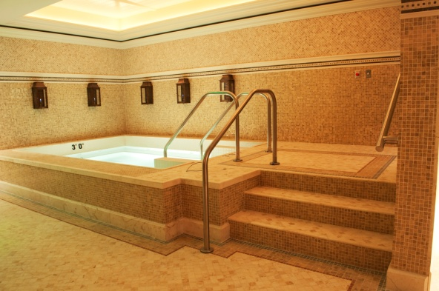
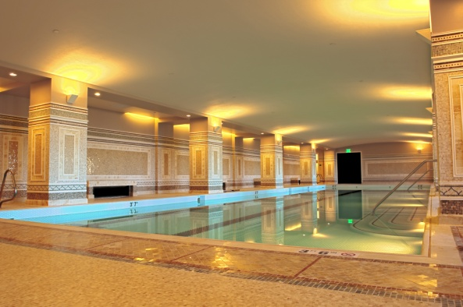

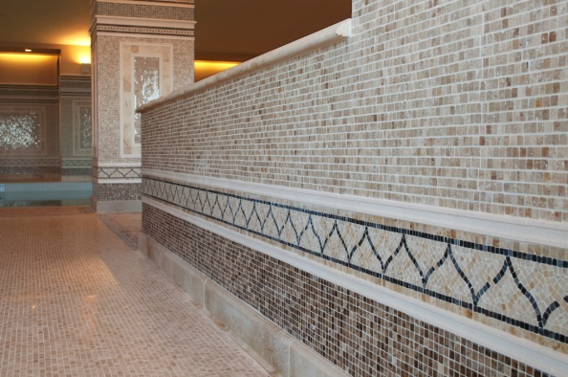
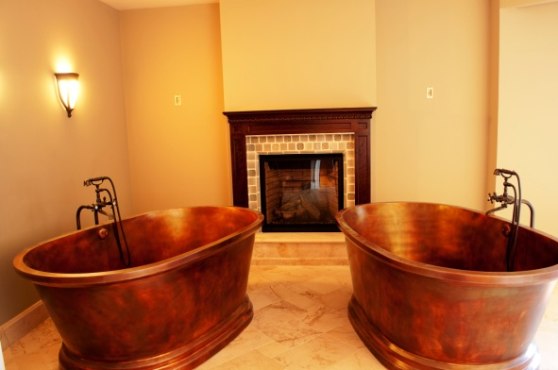

The mosaic work of the artisans at Caffall Tile & Marble

