A Gift That Elevates the Nursing Profession
MAPEI Tile & Stone Installation Systems Help Beautify TWU School of Nursing in Dallas
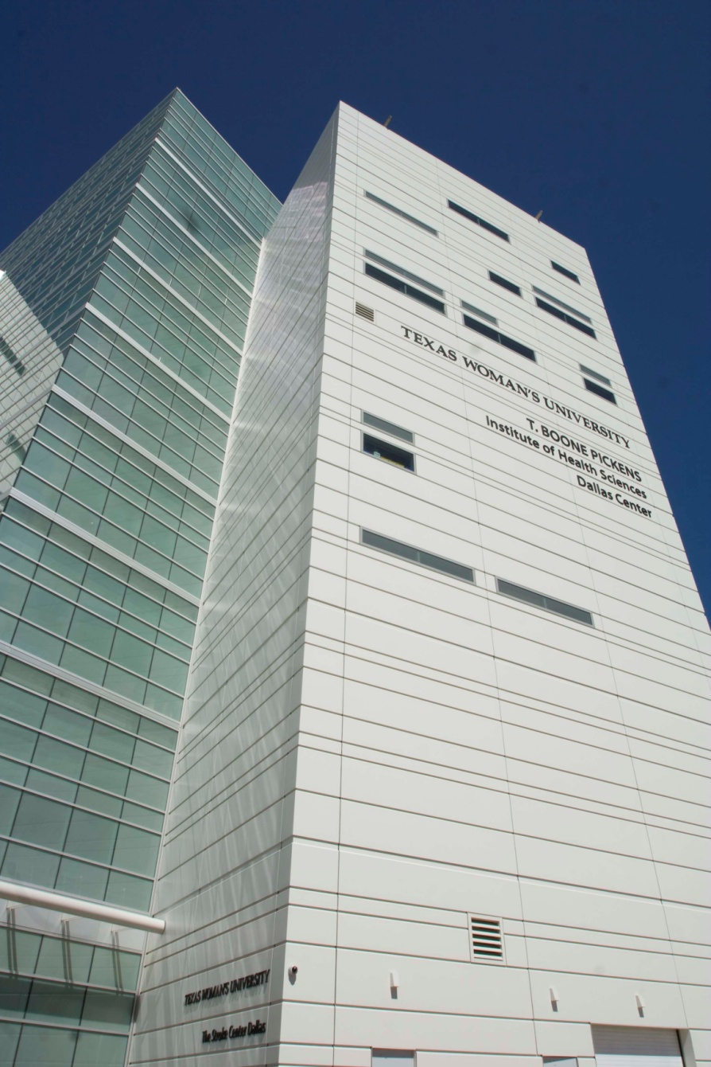
Texas Woman’s University has achieved new heights in merging teaching and technology to improve patient care with the opening of the TWU T. Boone Pickens Institute of Health Sciences-Dallas Center. TWU’s new Dallas Center bears the name of the Texas oilman and entrepreneur who donated $5 million to the building’s fundraising campaign in 2006. Approximately 50 percent of TWU students major in nursing and healthcare fields, and more than 900 of those are nursing students in Dallas.
The eight-story, 190,000-square-foot Dallas Center houses the university’s College of Nursing, the TWU Stroke Center-Dallas and the health systems management program, and by January 2012, will be home to TWU’s occupational and physical therapy programs. The Dallas Center is built to LEED (Leadership in Energy and Environmental Design) Gold Certification standards in keeping with TWU’s goal of reducing its carbon footprint. The health center is designed to maximize energy efficiency through its site orientation, insulated exterior façade and high-efficiency glass.

HKS, Inc.’s Educational Group designed the Dallas Center with a large awning that covers the entrance to the lobby of the Stroke Center. It was decided to carry out the design theme by installing light and dark bands of limestone throughout the lobby and first floor to be set at the same angle as the awning projected from the building. This decision carried a particular challenge for the installation crews from Dee Brown, Inc.
A pattern of stone was chosen, involving alternating bands of Crema Genova, a light limestone from Bulgaria, and a darker limestone from Tunisia. To accommodate the ¾-inch thick stones, the floors had been recessed in the lobby and first-floor hallways. The Dee Brown crews first made a mud pack using a 3-to-1 mix, to which they added MAPEI’s Planicrete® AC concentrated latex admixture to enhance its performance.
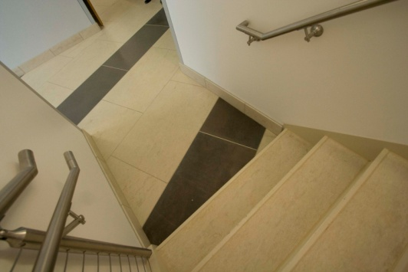
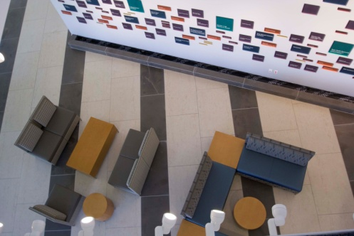
Project Manager Justin Daniels worked with the Technical Services Department of MAPEI and local representative Bobby Crow to determine which MAPEI mortar would best serve their purposes. After all the testing was done, Daniels selected Ultracontact RS for its rapid-setting properties that would allow complete drying behind the 2 ½-foot by 4-foot stones they would be installing. Because Ultracontact™ RS is a full-contact mortar, it can be used in thin-set and medium-bed applications with all sizes of tiles. Its superior wet-out characteristics achieve outstanding transfer to the back of the tile and eliminate the need for back-buttering. It is more fluid than traditional mortars, yet holds its ridges regardless of trowel size, which helped the Dee Brown crew place the 80-lb. stones and make slight adjustments for the setting angle.
Ultracontact RS is FastTrack Ready™, allowing for grouting in 3 to 4 hours. For the joints of these large stones, Daniels chose Keracolor™ U unsanded grout, which gave an ultra smooth look to the joints and left no marks of discoloration on the limestone.
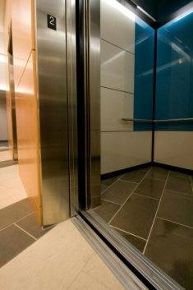
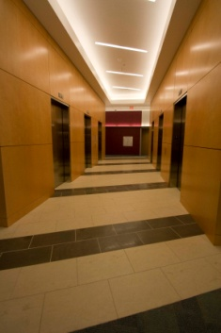
Modern Tile & Stone of Dallas collaborated with Dee Brown on this project. Following the pattern of light and dark brown stone, Clint Bunch and his crew from MTS placed smaller versions of the limestone at the same 20-degree angle in the elevator lobbies on four floors of the building. They also used Ultracontact RS and Keracolor U for these installations. Inside the elevator cabs, they installed the stone with Granirapid mortar and grouted with Keracolor U.
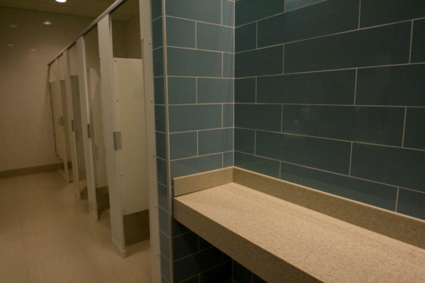
MTS installed tile in the public restrooms throughout the Health Sciences Center. They set 24” x 24” tiles on the floors, using Ultracontact RS and placed 6” x 22” blue and white porcelain tiles on the walls with Ultralite Mortar™. The non-sag qualities of Ultralite make it the perfect mortar for wall tiles this size. All tiles in the restrooms were grouted with Keracolor S.

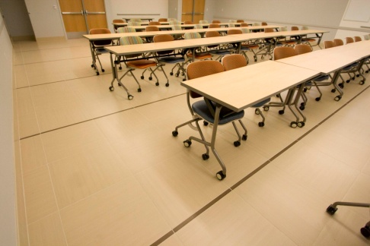
In one of the large classrooms for the school of nursing, MTS crews set 24” x 24” European tile with a linen look highlighted by 1” x 24” strips of the same tile in a darker color. The tiles were ordered direct from the factory, and MTS did not have to cut them. They set these tiles with Ultracontact RS and grouted with Keracolor S.

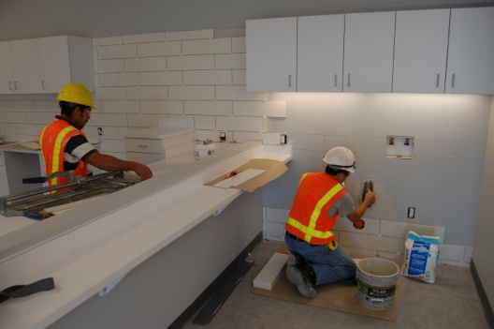
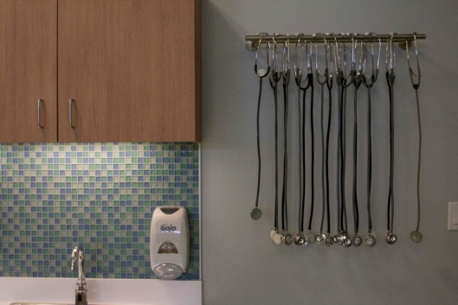
For the third floor break room, which serves all the educational programs in the building, a 1” x 1” glass mosaic tile was used to install a backsplash that extended up the wall above the counters. The same mosaic glass tile was installed in the nursing school laboratories as a backsplash behind sinks. A complimentary 6” x 24” white porcelain tile was used to tile additional space around the lab area. For these tiles, MTS crews set the tiles with Ultralite Mortar and grouted with Keracolor S.
By working closely with Kevin Psencik, the project manager for general contractor Austin Commercial, Clint Bunch and Justin Daniels were able to coordinate their work to bring the project in on time, on schedule, and in synch with the building theme. MAPEI is pleased to have been their choice for making it all come together. Together, everyone achieved the goal of T. Boone Pickens to give a gift that elevates the nursing profession at Texas Woman’s University.

