Getting into the Spirit of Sports
MAPEI Total Solutions Lead to High Spirits at Complexe Sportif de Gatineau
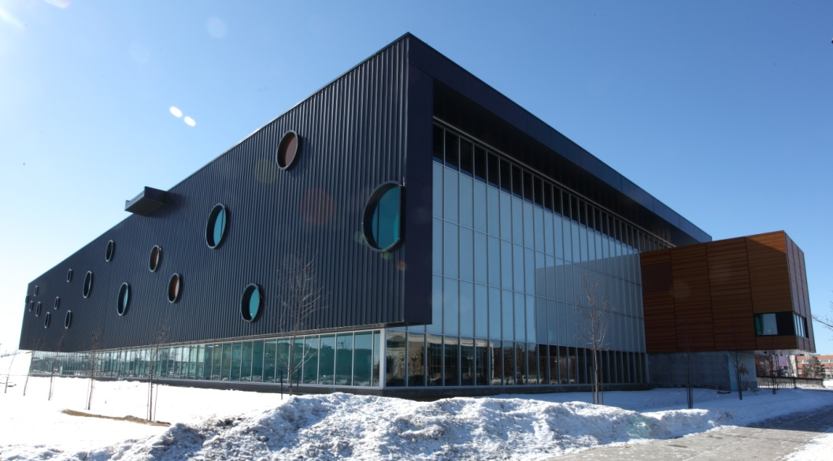
On June 14, 2010, the city of Gatineau officially opened its new sports complex. According to the city, the centre’s “18,500 square meters accommodate a number of sports, including volleyball, gymnastics, water polo, swimming, synchronized swimming, diving and underwater hockey. Its advanced sports and recreational equipment are available to the general public and to Gatineau athletes training for excellence.”
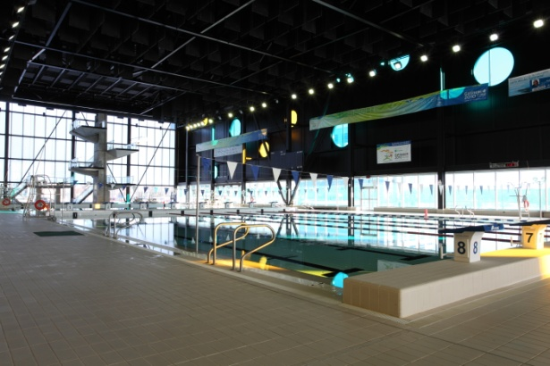
The new sports centre will be home to the national men's volleyball team training headquarters for the next four years. Other local and regional sports associations will also have offices there. In addition, during the Jeux du Québec de 2010, which took place from July 29 to August 6, the new centre served as the main venue, namely for swimming, basketball and volleyball.
The current excitement about fitness and competition fits well with the new sports center. A lot of work and effort went into constructing the facility between 2008 and 2010, and MAPEI products were used extensively for concrete repairs and surface preparation, as well as tile and floor covering installations.
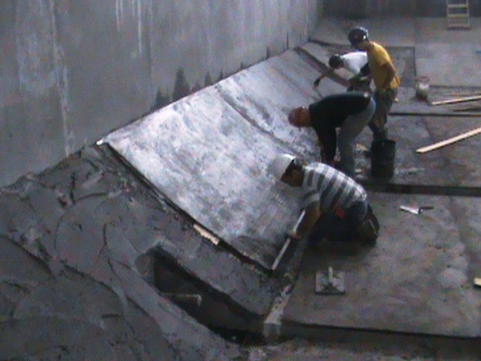
To allow athletes to train for regional and national competitions, Decarel Inc. constructed an Olympic-sized pool at the venue. To bring the pool into a “true” form, crews troweled Planitop® 23 concrete repair mortar onto the walls and screeded it to the exact proportions to meet competition requirements. Mapecem® 202 was used to level and true the floor of the pool. Before the Mapecem 202 was placed, the crews applied Planibond® EBA epoxy bonding agent to the concrete to enhance the bond between it and the repair mortar. Mapecem 100, a high-build, fast-setting construction mortar was used to fill in voids around drains on the deck.
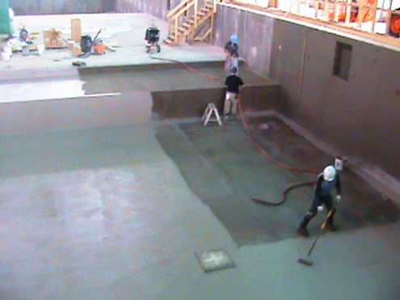
When repairs to the pool were finished, crews coated the walls and floor with Mapelastic™ Smart waterproofing membrane. A two-coat process was used. Fiberglass mesh was embedded in the first coat and covered with a second coat of Mapelastic Smart. The beach along one side of the pool and the shower rooms were also waterproofed with Mapelastic Smart before the tile was set.
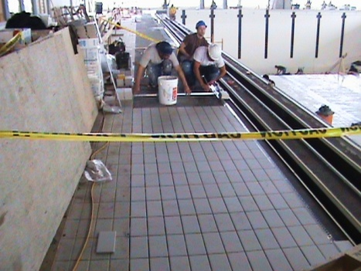
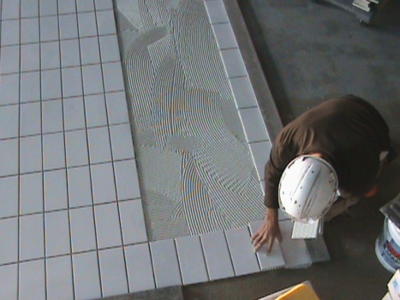
Once waterproofing was complete, crews from Jacques Lamont Ltée installed 25,000 square feet of porcelain tile on the walls and floor of the pool, using the Kerabond/Keralastic™ mortar system and grouted with Opticolor™, a non-sagging, efflorescence-free grout with no shrinkage. This grout is a water-cleanable, reaction resin product with chemical and stain resistance.
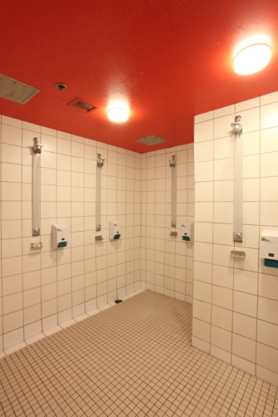
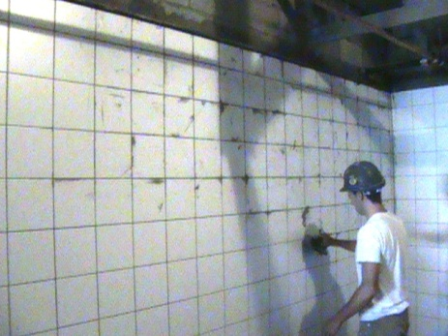
On the deck and in the shower rooms, an additional 10,000 square feet of tiles were set with Ultraflex™ 3 mortar, and the joints were grouted with Ultracolor® grout. Type 1 adhesive was used to set the wall tiles in the changing rooms. The installation crew also Mapecem Quickpatch in the main changing room to repair a frozen slab before tiling there.
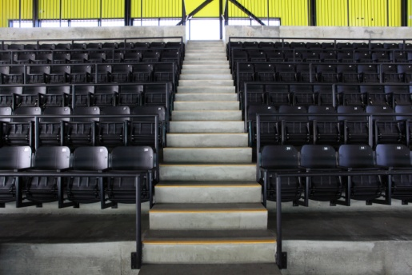
In the gymnasium, where the volleyball and basketball courts hold the spotlight, more MAPEI systems solved issues for this venue. The concrete viewing stands for the games needed some repairs. In this case, Planitop XS, a sculptable repair mortar, was used to straighten and properly level 350 steps. The crews injected Planibond CR-50 in certain areas where cracks had occurred. At the top of the stands, Ultratop® gray self-leveling micro-topping was used to cover exposed aggregate and make a repair 70 feet long by 5 feet wide. The gray color of Ultratop made the repair look uniform with the rest of the concrete area.
On the floor of the gymnasium, a Jacques Lamont team applied Primer L and then poured Ultraplan 1 Plus self-leveling underlayment to meet the FIVB (Fédération Internationale de Volleyball) standard for flooring. MAPEI’s Ultrabond G19 was used to cover the joints in the plywood that was laid over the Ultraplan 1 Plus. Then the Jacques Lamont crews used Ultrabond ECO 350 adhesive to install 18,000 square feet of rubber flooring. This universal adhesive offers the unique flexibility of installing floor coverings after a short flash time or once the adhesive exhibits pressure-sensitive characteristics.
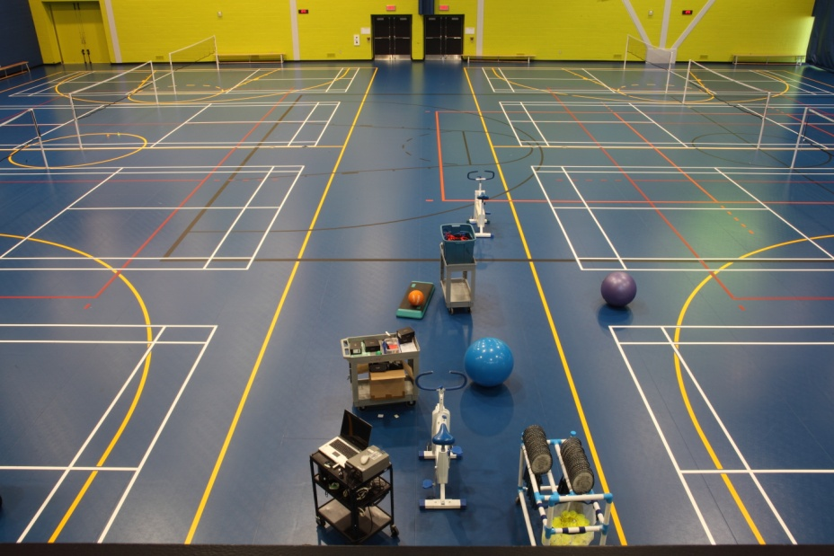
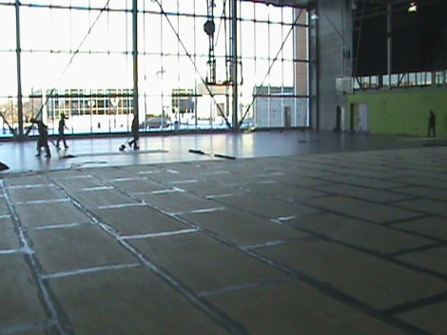
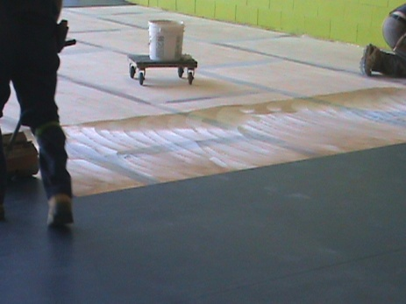

The city of Gatineau is very proud of its new sports center. With the help of MAPEI’s total solutions, we can say “Game well played, everyone!”

