Complexe Jules-Dallaire – the Essence of Business Life
MAPEI Products Help Give 17 Floors the Professional Touch
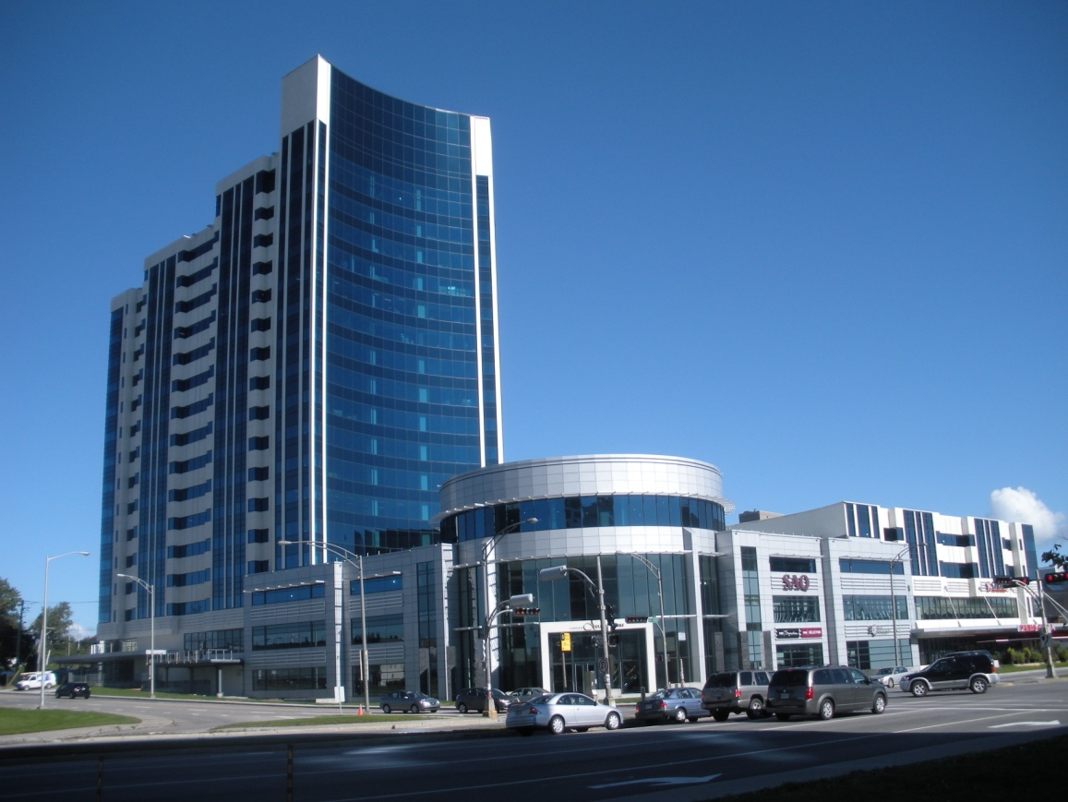
Complexe Jules-Dallaire has been developed near the historical sector of Quebec City by Cominar Real Estate Investment Trust. The Late Jules Dallaire was the founder of Cominar as well as a renowned real estate developer in the Québec City area.
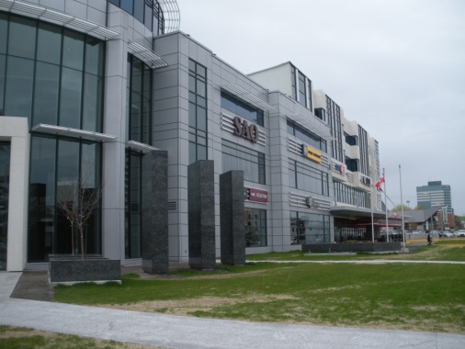
The first and second floors of the complex extend lengthwise across the 130,000 square feet of commercial property and are occupied by retail stores, banks and restaurants. Floors 3 through 17 of a high-rise office tower extending above the first two floors on the southwest side of the complex are leased to law firms, government agencies and other professionals. This tower has been named the Ogilvy Renault Tower for the prestigious law firm that occupies the top three floors of the high-rise section. The complex is registered for Canadian LEED Gold status.
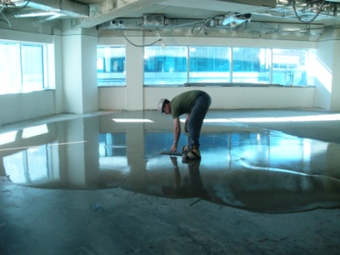
Dalcon Inc., the construction arm of Cominar, did much of the finishing work on the structure. On each level of the building, they measured the highest and lowest spots. Then they applied Primer L or Primer T to the concrete and topped it with Novoplan® 2 self-leveling underlayment. Novoplan 2 is well-suited for leveling, smoothing and repairing interior floors before the installation of floor coverings. Ceramic tile and natural stone can be installed 24 hours after application. Engineered wood plank can be installed 1 to 3 days after application, depending on the thickness of application.
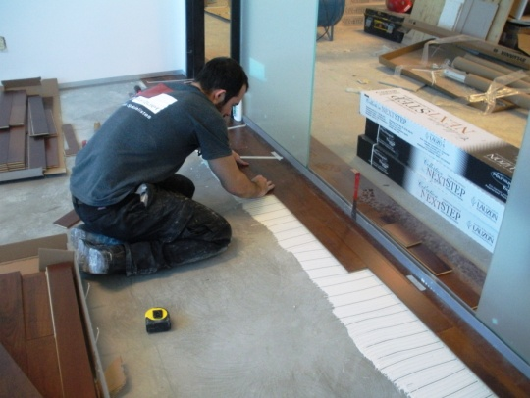
On the 12th floor, a different solution for self-leveling was employed. CP Pelletier, the floor covering installer, used Primer T and Ultraplan 1 Plus to level the concrete because they needed the underlayment to cure quickly so they could install the wood flooring and carpet. Wood flooring was installed by Multiparquet, a subcontractor of CP Pelletier, using Ultrabond ECO 995. BCF Avocats (attorneys) occupy the 12th floor, and ECO 995 was used for its sound-reduction properties. It was also instrumental in installing the wood flooring at the same height as the square carpet next to it.
The Dalcon crew used Mapecem 100 as a topping to smooth and level the concrete at the entrance area to the complex. A steel grate was placed over the Mapecem 100, so that visitors entering the building in the winter can scrape snow from their boots.
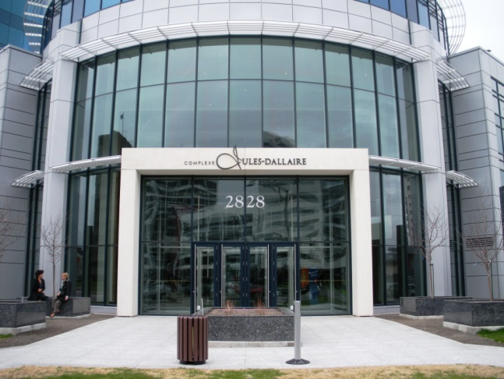
Outside of the complex, there are several decorative granite columns and planters. The granite cladding on these structures was installed with the Granirapid® mortar system, and the joints were grouted with Ultracolor Plus® “Charcoal” grout.
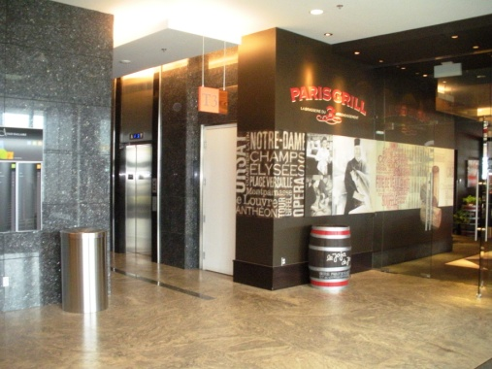
The same granite was installed on vertical surfaces in the interior of the building using Granirapid and Ultracolor Plus. On the first and second floors, the granite makes a dramatic statement in many of the areas outside shops and restaurants. On all 17 floors of the Tower, the same granite was used to surround the elevator lobbies.
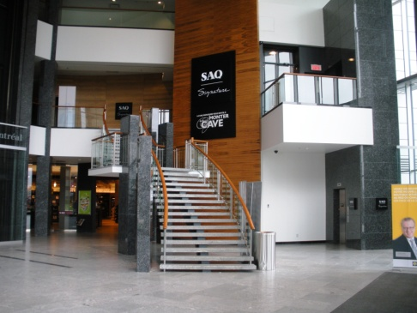
In these same areas, a striking gray stone was set on the floors with Ultracontact™ mortar for complete coverage without backbuttering, saving the installers time and labor. The gray stone was grouted with Keracolor™ S sanded grout. In areas where speed was needed, Ultraflex™ RS mortar was used to set the tiles.
Ultraflex LFT was used to install the tile in the public restrooms on each floor; and these ceramics were grouted with Kerapoxy® grout for the ultimate in stain resistance. In total, tiles were installed in 40 restrooms spanning the 17 floors of the complex.

To add to the classic look of the elevators, Dalcon crews installed tiles on the floors of the elevator cabs. The stone on the steel floors inside the elevators was set with Planicrete W to give maximum bonding between the stone and metal.
A circular stairway made of metal was treated in a slightly different way. The installers applied Planibond EBA epoxy bonding agent to the stairs and broadcast sand onto it, then set ceramic tiles over it.
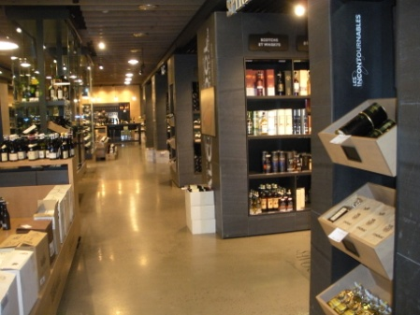
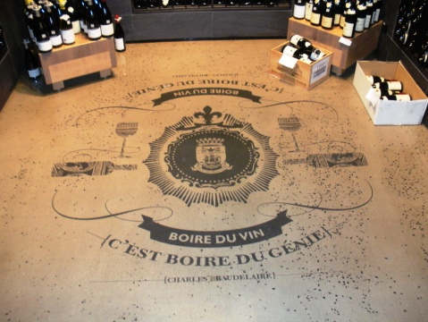
Each of the establishments leasing space at Complexe Jules-Dallaire finished their floors and walls to their own tastes. One unique treatment was requested by one store. The Société des alcools du Québec (SAQ) is a government-owned corporation responsible for the trade of alcoholic beverages within the province of Quebec. For this upscale retail outlet, dark gray stone was installed on vertical surfaces that form the racks for wines and liquors. Polyjet, a local decorative concrete company, poured Ultratop® self-leveling micro-topping with stone aggregate to provide an artistic surface to the floor. In certain areas they decorated the concrete with the SAQ logo and other designs.
This summer Cominar Realty Investment Trust will be starting construction of a second, 29-story tower on the northeast side of the site. Half of this building will be developed for offices, while the other half will be constructed as residential condominiums. MAPEI hopes to be part of this continuation of the construction of Complexe Jules-Dallaire.

