Ferrari and Maserati Stand Out by Design
MAPEI Products Smooth the Way at New Vancouver Dealership

On January 11, 2011, Ferrari announced that 1750 of their cars had been sold in the United States and Canada during 2010, a 20% increase over the previous year. And Maserati sales increased 48% through November 2010. With Ferrari price ranges from $200,000 to $350,000 for a basic model, it’s easy to see why this is exciting news for one of the most well-known marques in the auto industry.
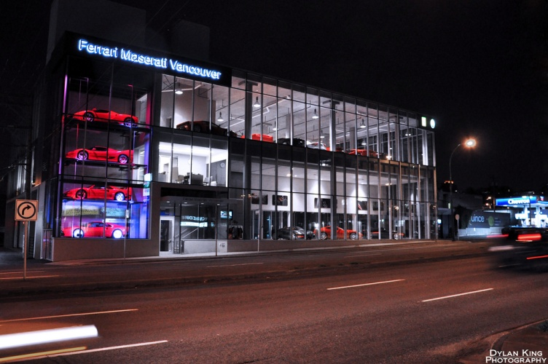
The Ferrari and Maserati brands have never hidden from the limelight, but ownership of factory-authorized dealerships is a pretty exclusive club. In Canada, there are only five dealerships – one in Quebec, two in Ontario, one in Alberta, and the latest in Vancouver, British Columbia.
Because it was a Ferrari Maserati dealership, expectations for the venue were high. The company originally hired to be the general contractor for the construction of the dealership did not meet the high standards of the owner. After seeing the concrete work that was provided, the owner hired his own project manager to finish the project. Every floor in the building appeared wavy and uneven and required resurfacing to properly display the famous cars.
The floor in the mechanics’ shop / repair shop was to be covered with an epoxy coating, so the floor needed to be sloping to the drains but nice and flat otherwise. LT Concrete Services Ltd. used Planibond® EBA as a bonding agent for the existing floor, and then topped it with a layer of Mapecem® 202, a fast-setting cementitious repair mortar that could be screeded to achieve just the right slope.
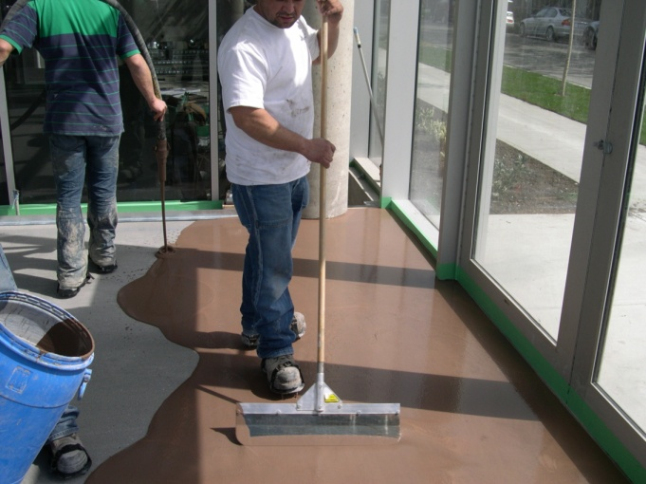
In the first floor showroom, the Ferraris and Maseratis would catch the eye of passersby, and the owner wanted a background that was faultless, yet would not distract the viewers from the main attraction. For this floor, Primer E was applied, with a sand broadcast, followed by a topping of Ultraplan Easy self-leveling underlayment. Ultraplan Easy goes down fast and easy, saving time and labor for the contractor and owner. An epoxy coating was applied in this showroom area afterwards.
The showroom area is extended to the second floor, with the addition of an office area for discussing all the details to customize or personalize purchasers’ choices. For this floor, Primer E was also used with a sand broadcast; and the floor was again topped with Ultraplan Easy and an epoxy coating.

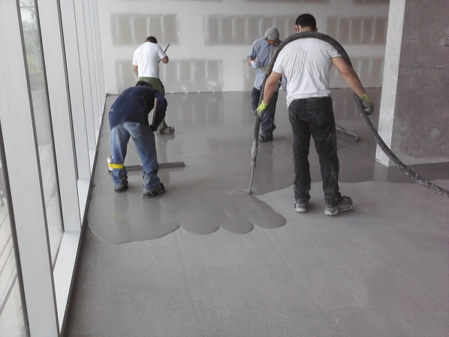
The third floor of the dealership is used for storing vehicles and for office space. This floor received Primer E with sand broadcast, followed by a topping of Ultratop Natural Gray self-leveling concrete topping. The natural gray color was selected so that a clear sealer could be applied over top of the Ultratop. The crew from LT Concrete did a superior job of creating a smooth, unmarked surface with their application of the Ultratop.

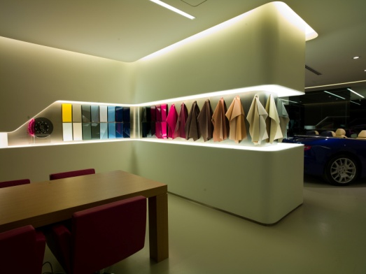
On Saturday, November 13, 2010, over 500 guests met to celebrate the grand opening of the new state-of-the-art, 35,000-square-foot Ferrari Maserati facility at 1860 Burrard Street. To their delight, 21 fascinating examples of Italian automobile craftsmanship were displayed over the three stories of the glass-fronted dealership. The cars certainly stood out, enhanced by the ultra-smooth concrete floors that held them like a velvet cloth cradling some of the world’s most exclusive gemstones.
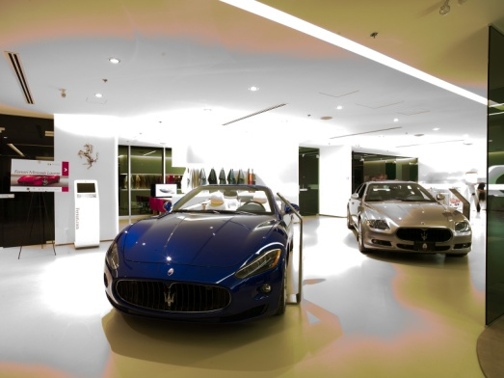

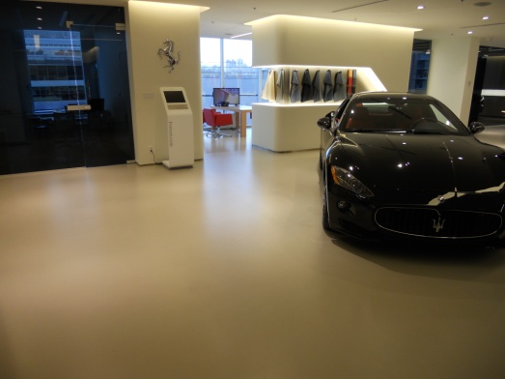
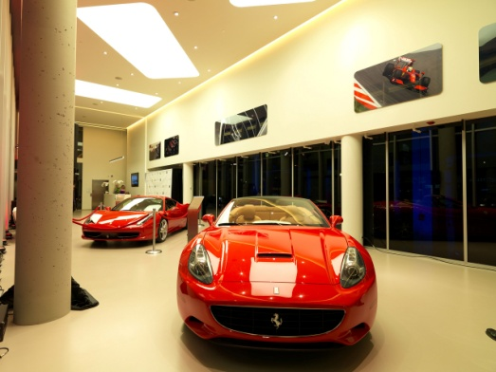

Such great cars! Such great floors!

