Jameson House – Luxury Thinking Outside the Box
MAPEI Products Work with Radiant Heating System to Warm the Stone
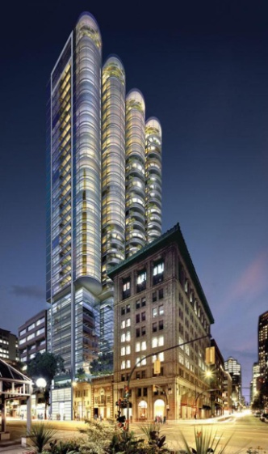
Jameson House is a mixed-use residential building, 38 stories high, located in the heat of Vancouver. Architect Nigel Dancey of Foster and Partners (London) designed the high-rise towers with curved window surfaces, to give a feel of openness to living in the city. The project began in November 2008 but was stalled as bank financing as withdrawn due to global economic problems, and all work was stopped. Then, in 2010 Bosa Properties took over the project and Bosa Construction became the general contractor.
Planned to LEED Gold standards, the building’s exterior form and design of the façade were determined by the direction of prevailing winds as well a solar exposure. Photovoltaic cells are employed on the south façade where there is maximum exposure to sunlight. The building features Vancouver’s first cogeneration plant, which is powered by bio-diesel.
This green project carefully restored and integrated two heritage buildings to create a mixed-use building with retail and restaurants on the bottom three floors, followed by eight floors of office space and then topped with 27 levels of condominiums. The heritage site restorations included the full restoration of the A-listed 1921 Ceperley Rounsfell building and retention of the front façade of the B-listed Chamber of Mines.¹
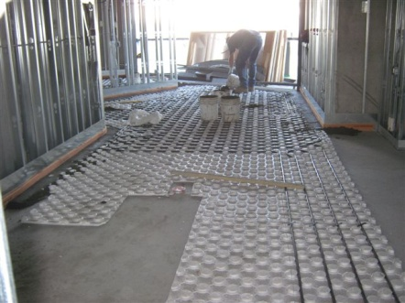
The architect selected the Bekotec System with hydronic pipes to heat the residential units in the tower. MAPEI representatives Dave Randall and Al Andreassen were called in to view the start of the installation of the Bekotec Styrofoam units over the concrete suspended slabs in the lower units. After much debate, it was decided by Bosa that they would encapsulate the Pex water piping that was used with the system by using a 4-to-1 mix, though this was not MAPEI’s preferred recommendation.
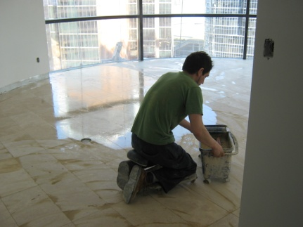
After the installation of the 4-to-1 mix mud bed was complete on the lower floors, Bosa decided to use the Schluter Ditra mat over top of the mud bed. Ican Contracting, the installation arm of one of MAPEI’s distributors, set the mats with Ultraflex 2 thin set mortar. Because there were many areas where natural stone had been specified as the finished flooring product, Ultraflex LFT mortar for large-format tiles was used for this procedure. The Ican crews also used the Kerabond/Keralastic mortar system to back-butter the natural stone.
A combination of MAPEI’s Keracolor S and Keracolor U were used for grouting the joints between the stones. Though this is not a recommended MAPEI practice, the Ican crew used the combination of products in this instance because the large joint size would have been difficult to fill with an unsanded grout (Keracolor U) alone. Ultracolor Plus grout could have been a good option for this large grout, but the developer wanted the smoother finish provided by the mixture of Keracolor S and Keracolor U.
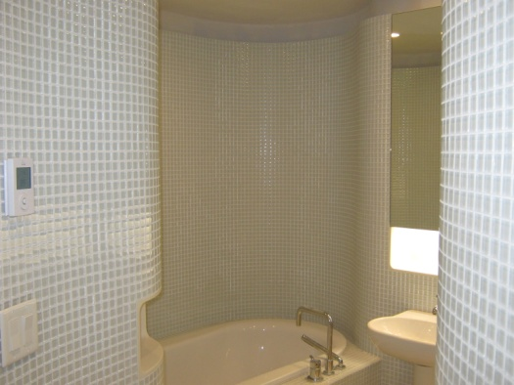
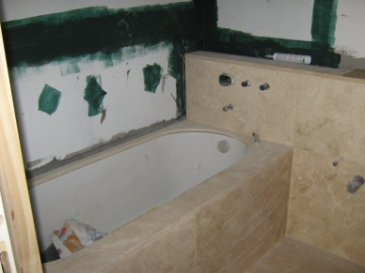
Bathroom walls in the 131 residential units were waterproofed by using meshed tape over the joints, followed by a coating of Mapelastic AquaDefense. The shower floors were coated with Mapelastic 315, and mesh tape was also used here. The larger stone in some showers was set with Ultraflex LFT.
Certain of the residences included special green planning. These “Organic” suites incorporated different modern and ergonomic designs. For the glass mosaic tile in these bathroom suites, the Ican crew used Adesilex P-10 bright white mortar to enhance the beauty of the glass tiles.
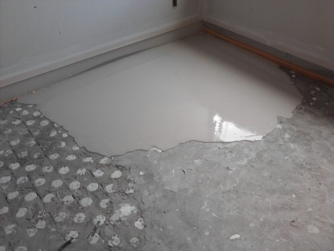
In the hallway areas outside the residential units, MAPEI’s Planitex SL35 was used to level the concrete floor, ranging from ½” to 3” deep. Planitex SL 35 is a gypsum-based, self-leveling underlayment with an exceptionally smooth, hard surface for use in dry interior residential and commercial areas. It is designed for application at depths of 1/4" to 3" (6 mm to 7,5 cm). These areas were covered with carpet several weeks later, so the Planitex SL35 had time to dry properly.
Because Planitex SL 35 can be used to cover radiant or in-floor heating systems, it was also used in the suites in the bedroom areas to encapsulate the pipes in the Bekotec system and to also level the floor prior to the later installation of carpeting.
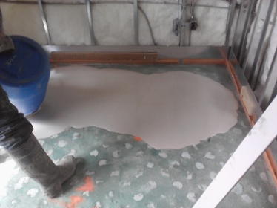
In some of the suites in the towers, Planitex SL was used to level the floor over the 4-to-1 mix if the mud bed was not quite level enough, or in areas where the elevation was just a little low. Planitex SL was also used in the hallway areas in front of the elevators under the carpeting. The concrete floors in these areas required leveling in depths from feather edge to 1 inch, a perfect application for Planitex SL. The crews used Primer T on the concrete prior to the application of the Planitex SL to achieve the best bond.
Jameson House has a 7-story underground parking garage that was planned to efficiently maximize use of space. An automated car parking system delivers residents’ cars from parking stalls to the P1 floor area via car dollies and elevators. The dollies run on tracks in the underground parking area. The concrete floors must be perfectly flat in order for the tracks to have full support. Mapecem 202 fast-setting concrete mortar was used in several locations within the garage to fill in low areas and offer that support.
Planitop X was used to fill in and patch holes in some walls in the underground parking area, and Tilt Finish was used to skim over some walls as well as improve the appearance of the walls.
Green and sustainable building is important to Vancouver, and MAPEI is proud to have been an important part of the flooring solutions at Jameson House.

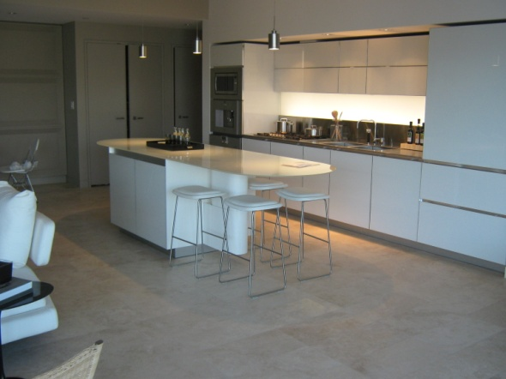

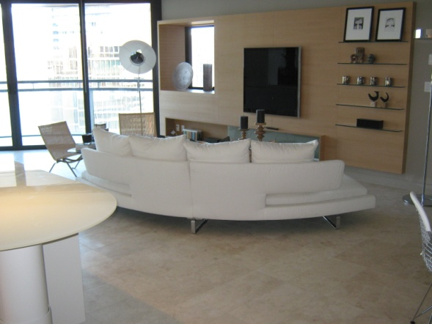

¹Information on the green aspects of Jameson House provided by Emporis (http://www.emporis.com/application/?nav=building&lng=3&id=jamesonhouse-vancouver-canada)

