Patina Tower Rejuvenates YMCA Heritage Site
MAPEI Products “Level” It All
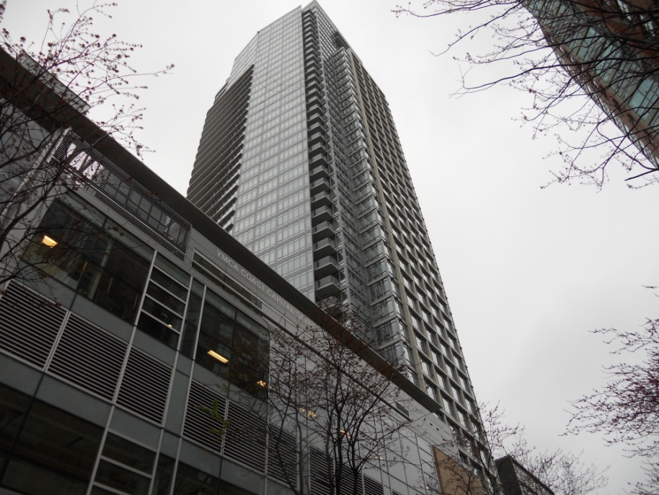
Some companies just build, but Concert Realty Services in Vancouver rebuilt the past while constructing the future. The Vancouver YMCA was opened in 1941, and for some time it struggled with how to generate the funds for a much-needed revitalization at its central downtown location. Concert Realty acquired the property behind the YMCA (which faces onto Burrard Street) for residential development and proposed a joint-development venture.
Patina would be constructed as a luxury 42-storey high-rise with 261 condominium homes offering unobstructed and panoramic views of the city, water and mountains. At the same time, Concert would develop the adjoining 95,000-square-foot state-of-the-art downtown YMCA.The new YMCA downtown redevelopment and the residential tower would share a common adjoining wall that would serve as a physical symbol of the joint venture between a private organization and developer, demonstrating the benefits to both.
Although the construction proceeded as a single project, Patina and the rejuvenated YMCA were built in two separate structures. Though sharing a common wall, but they both have private entrances. The YMCA’s top story serves as a rooftop garden that can be used by the residents of the tower. Synergies are expected to be created by the tower residents and the YMCA facilities, although the Patina tower also has its own recreational facilities.
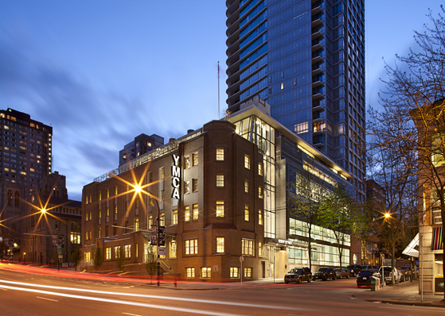
A 30-foot deep, brick, heritage front from the original YMCA was retained for restoration, but the rest of the facility is entirely new. The building was named after Mr. Robert H. Lee, a Vancouver-born entrepreneur and philanthropist, in recognition of his leadership donation towards the new facility. A member for 45 years, Mr. Lee made the YMCA a part of his daily life.
The six-story daycare and fitness centre contains whirlpool, steam rooms, change rooms, gymnasium and aerobic studios, conditioning, weightlifting and fitness areas as well as classroom and offices. The developer, Bosa Properties, achieved a Bronze LEED certification for the building.

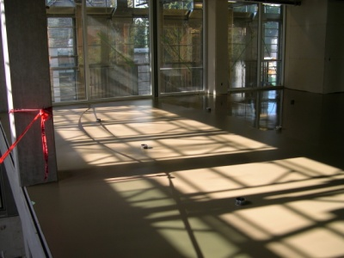
MAPEI played an important role in the refurbishment of the YMCA heritage building with its self-leveling products. Bosa Construction crews used Ultraplan Easy to level four floors that were approximately 2,000 square feet each, ranging in thickness fro ¼-inch to 2 inches. Primer L was used to prime the concrete. In the gymnasium and racquet ball courts, the floors were also leveled with Ultraplan Easy prior to the rubber flooring being installed.

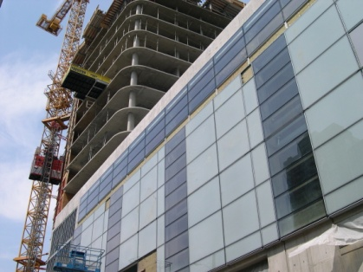
Bosa Construction also used MAPEI’s self-leveling products extensively in the Patina tower. Each of the 42 floors in the tower required leveling in the suites and in the hallways. Approximately 8 to 12 pallets of Novoplan Easy were used to level each floor, resulting in a 130,000-square-foot total pour. Bosa bought a new Machine Technologies MP25 rotor stator pump to help assist in performing this very large leveling job.

The work in these two buildings shows that MAPEI can bring a “level” playing ground to the old and the new, truly “technology you can build on.”

