**New Kauffman Center Harmonizes with Kansas City**

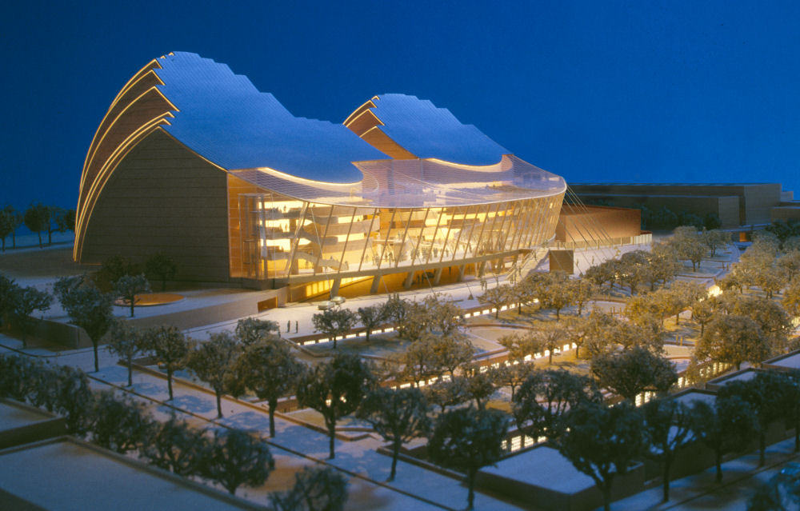MAPEI Products Provide Total Solution for Flooring Needs at Performing Arts Center

The Kauffman Center for the Performing Arts has brought a dramatic new venue to Kansas City, Missouri. J.E. Dunn Construction, the general contractor for the Center, provides the following perspective on the project:

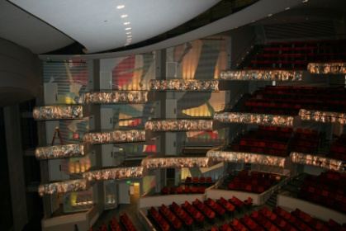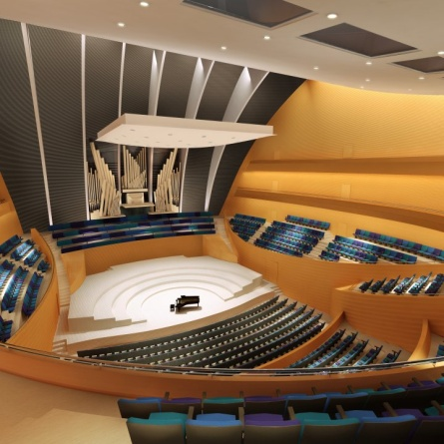“The Center, located at 16th and Broadway in the heart of the downtown area, features two state-of-the-art performance venues: the 1,800-seat Muriel Kauffman Proscenium Theater (home to the Kansas City Ballet and the Lyric Opera) and the 1,600-seat Helzberg Concert Hall (home to the Kansas City Symphony.

The Theater, the Hall, and the back-of-house areas are constructed of structural concrete and are separated by an acoustical joint to eliminate the transfer of sound from one area to the next.  All three areas are enclosed by a distinctive clamshell-shaped high roof consisting of structural steel, precast concrete, metal roofing and a cable-supported glass-system atrium. The project also includes a 4-level parking structure 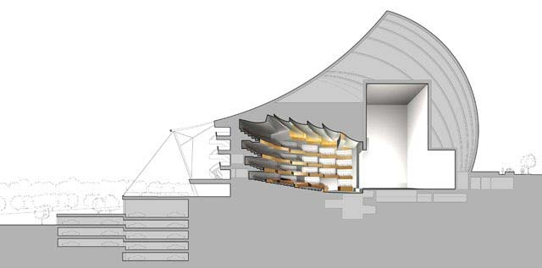that can accommodate 1,024 cars.

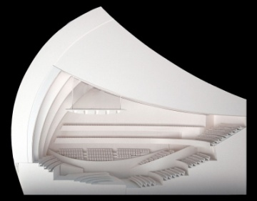Designed by Safdie Architects with the assistance of BNIM Associates of Kansas City, the nine levels of the theater and the 7 levels of the concert hall use every inch of space efficiently. The sheer complexity of the project mandated a full-time Building Information Modeling professional to create 3D models and 2D concrete placement shop drawings. (NOTE: All MAPEI systems for floor covering and concrete repair are in the BIM program on ARCAT.)

Although the Kauffman Center will not be seeking LEED certification, it does incorporate sustainable elements.  When the Kauffman Center was designed in 2001, the LEED process was only available for office buildings, not for massive entertainment structures; and redesign would have proved too disruptive and costly.  Still, the project provides green roofs, which reduce the effects of accumulated heat.  Also, since the building itself consists of a "box-in-box construction", it is inherently well-sealed and insulated, providing efficiency in excess of governmental standards.”

MAPEI delivered a total solution for the floor covering installations at the performing arts center. Though the glass-walled grand lobby floor was covered with stone set in a traditional mud bed, all other spaces were installed with tile, carpet and VCT that used MAPEI’s adhesives, mortars and grouts. MAPEI representative Dennis Sandell handled all the logistical and technical support for both the tile installer and the floor covering installer .

**Tiling the “Front of the House”**

There are a total of 70 bathrooms in the Kauffman Center. In the public spaces at the “front of the house”, this amounted to 10,000 square feet of tile that needed to be set on floors and walls. Crews from Midland Marble and Granite of Lee’s Summit, Missouri installed Graniti Fiandre 12” x 12” tiles on the bathroom floors and a special tile from England on the walls. The English tile, supplied by Stone Source of Boston was a 3” x 6” smooth tile called “Gypsum G30”. For this work they used MAPEI’s *Ultraflex 2* mortar and *Keracolor S* sanded grout on the floors. They set the wall tiles with *Type 1* adhesive and grouted with *Keracolor U* unsanded grout.

**Tiling the “Back of the House”**

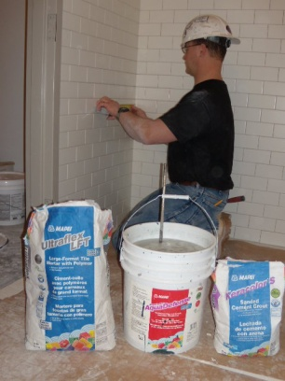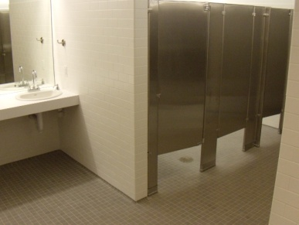“Out of sight” did not mean “out of mind” when it came to tiling the bathrooms and showers for the performers and staff of the Kauffman Center. At the back of the house, Midland Marble and Granite crews set 2” x 2” Dawn Gray mosaic tiles from American Olean on the bathroom floors and the floors of shower stalls. For the walls of showers and bathrooms, they used Daltile’s Rittenhouse Square 3” x 6” tiles. Floor tiles were set with *Ultraflex 2* and grouted with *Keracolor S*, while bathroom wall tiles were set with *Type 1* and grouted with *Keracolor U*. Shower tiles were set with *Ultraflex LFT* mortar and grouted with *Keracolor S.*

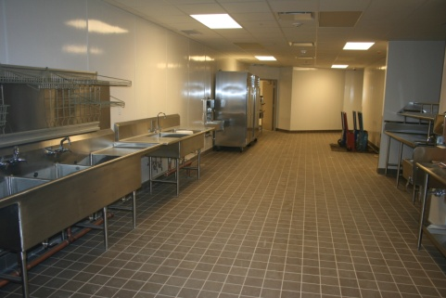In the back of the house, there is also a 2200-square –foot kitchen, designed to provide food and refreshments for the theater and concert patrons. In this area, the Midland Marble and Granite team set 6” x 6” Tempest Gray quarry tile from Daltile, again using *Ultraflex 2* mortar and *Keracolor S* grout.

Large commercial projects comprise more than 90% of Midland Marble and Granite’s installation work. Mike Dowell, the project manager for MMG, said, “We truly enjoyed working with J.E. Dunn on this project. They gave us plenty of time to complete the project, and we didn’t feel that we were ‘under the gun’ to get it done. Fortunately for us, there were no delays in the project, which helped things move along smoothly.” MMG has just finished another very large project in Kansas City – the Wizards’ Soccer Stadium. “We used all MAPEI for that project, too,” said Dowell. “We always use MAPEI.”

**Then There Was Carpet . . . and Vinyl**

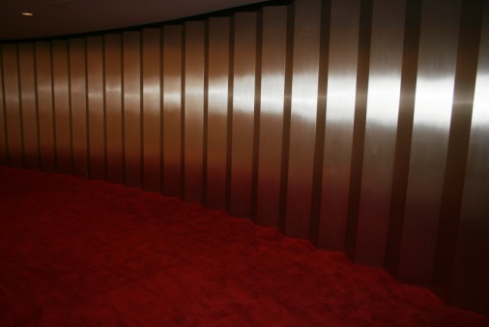Commercial flooring companies are only as good as the installation process. FDC Contract is the undisputed industry-wide leader in commercial flooring products, with superior installation and service in the Kansas City area. At the Kauffman Center the FDC crews had a huge canvas on which to create their own brand of artistry.

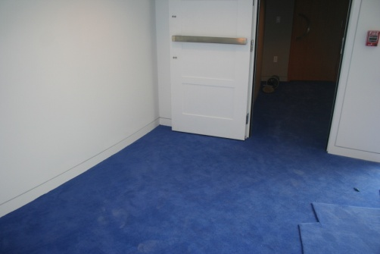The design team had selected nine different colors of Bentley Prince Street broadloom carpet in 3 different styles. The colors from the Kings Road series evoke an explosion of images – Chile Pepper, Basalt, Sapphire, Tunisian Red and Chambord. These varied hues were selected to match the color themes in the Concert Hall (blues) and the Proscenium Theater (reds).

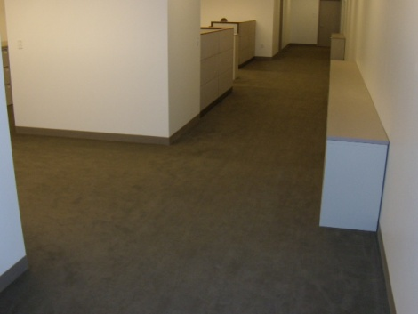Working from detailed layouts, the FDC crews installed nearly 75,000 square feet of carpet on seven different levels of the Hall and the Theater, plus 9 levels at the “back of the house” in office spaces and donors’ lounges. At the front of the house, carpet was placed on stairwells, in the orchestra pit and in the wings of the auditorium. One thing every piece of carpet had in common was the adhesive used for setting it. FDC used MAPEI’s *Ultrabond ECO® 285,* a FastTrack Ready™ product designed specifically for the installation of carpet with hot-melt backings. Its high-solids formulation has been developed for use in the wet-lay installation method, so that no flash time is required. Its rapid tack development and superior bond strength make *Ultrabond ECO* 285 the adhesive of choice for virtually all carpet installations*.*

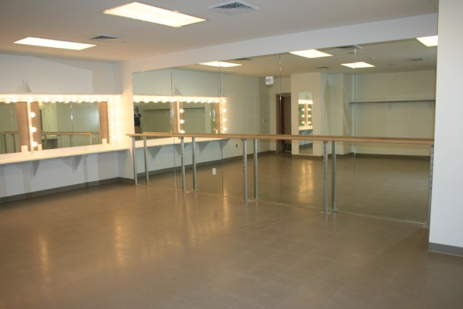FDC’s work wasn’t all about carpet. Vinyl composition tile (VCT) was placed in changing rooms, practice rooms, some technical work areas and some areas of the offices. For this job, the FDC crew used MAPEI’s *Ultrabond ECO 711* clear, thin-spread VCT adhesive to install more than 25,000 square feet of Armstrong’s StoneTex vinyl tiles in a shade called “Pumice Stone”. In addition, over 25,000 linear feet of Johnsonite 4” cove coils (wall base) in colors of “Pebble”, “Snow White” and “Grey” was applied with MAPEI’s *Ultrabond ECO 575* premium wall base adhesive.

“This was my last job with FDC before I retired,” said Rae White, the company’s lead for the Kauffman Center. “I am so happy that I could go out on a high note with a project like this one. We enjoy a great working relationship with J.E. Dunn, and it seems that we helped each other at every turn. Safdie Architects was very involved with the project and held weekly meetings to guide the direction of their vision for the Center. BNIM Associates, our local architectural firm had their design team on site every day, and we were able to provide them with solutions for any issues that arose in the course of our daily progress.”

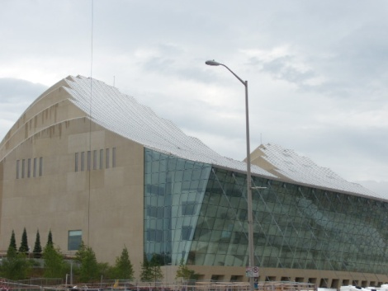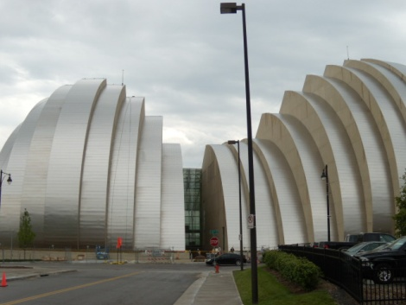Through excellent communication and joint efforts, all the trades involved in the construction of the Kauffman Center for the Performing Arts have brought a joyous sound to Kansas City. After their first practice rehearsal in the Helzberg Concert Hall, Michael Stern, Music Director of the Kansas City Symphony, said, “Whether you sit downstairs or whether you sit upstairs, what you feel from the stage is the same, there’s no loss of clarity.” All of the musicians seemed to agree with him, and so did everyone else present.

